GIT And GIT HUB
- GIT – git is a distributed version control tool and git is used to track the changes of our source code/project
- Types of version control
Distributed version control tool – GIT
Centralized version control – SVM
- In Distributed version control we have copy of original data and it works faster than centralized version control
- In centralized version control we don’t have a copy of original data and it is directly save in server repo
- Source code- in git source code means the program files(code) that are tracked and managed by GIT
- GIT HUB – it is a central repository/source code management tool to store the source code
- make a .git repository - git init
- Show working tree status - git status
- get complete details. Git & GitHub - git config –list
- to register username- git config --global user.name " "
- to register email- git config --global user.email " "
- to track files- git add filename
- to track all files- git add .
- git commit -m "relevant message" - to create a snapshot of the tracked files. (b112f36 is the example of commit id, used to reverse changes).'
- git log - to check logs, also useful to pull up commit id's.
- git remote -v - shows which remote repositories your local Git repo is connected to, and the URLs used for fetching and pushing.
- git remote add origin url - to add origin (fetch the repo url from GitHub by clicking on the green code button).
- git clone - helps to download all the data from central repository to local machine.
- git pull - helps to download all the changes made in the central repository.
- git revert commit_id - to revert changes
- git reset - resets the changes before committing
- If someone pushed a file in the repository and you do not have it locally, then if you push without fetching the data then the push fails.
- Use Fork option to copy repositories to your account from public repos.
- Git Hub account
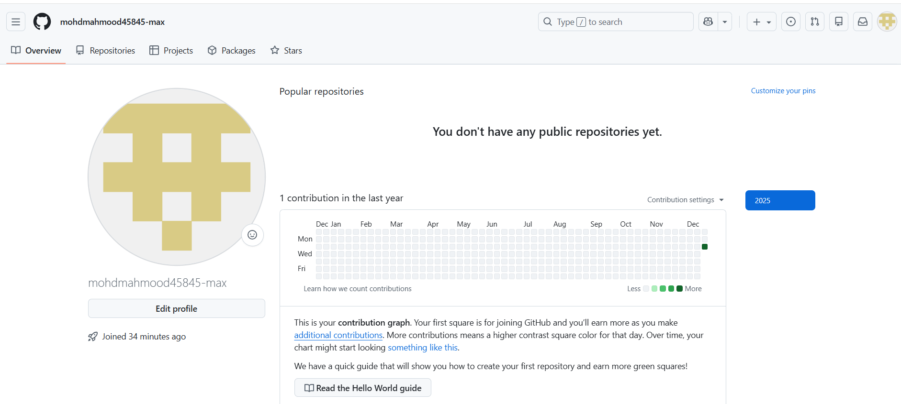
- Created file and move to untracked to tracked
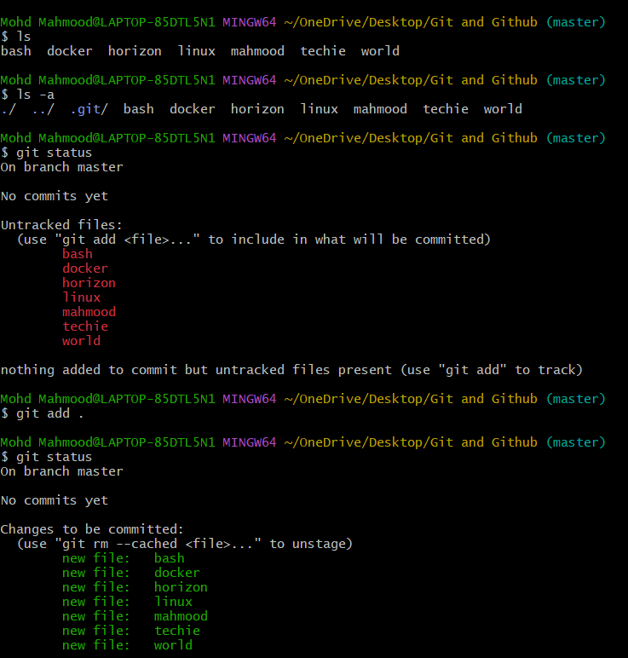
- Commits (to store the changes)
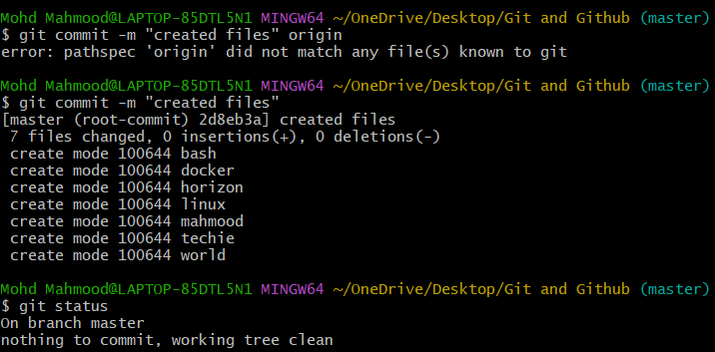
- To get the commit id
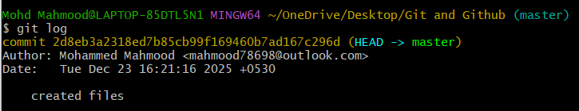
- To create a new repository and add the ssh link in git
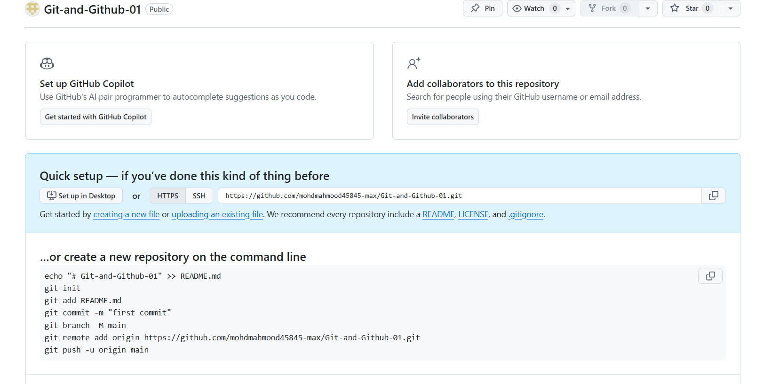
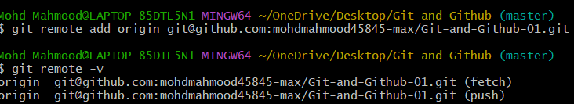
- Creating a key
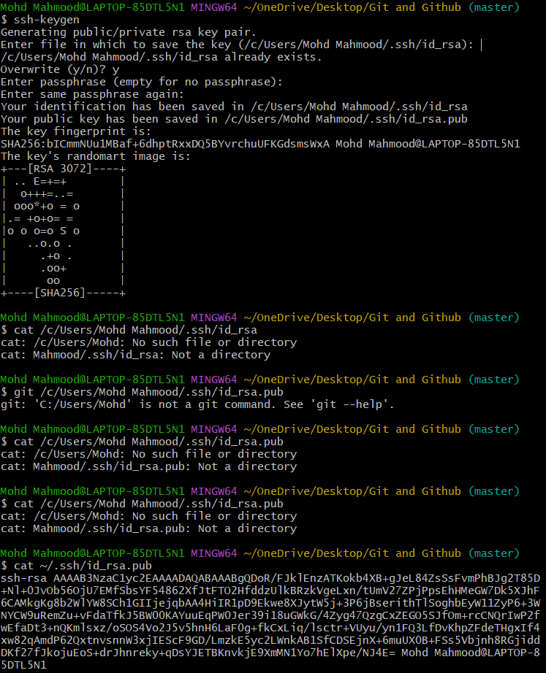
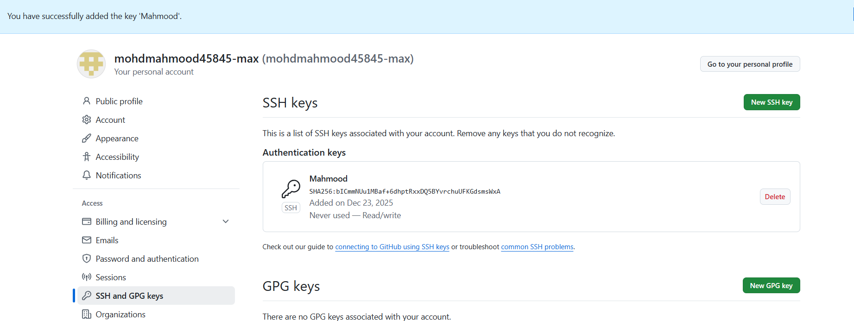
- Push the files from local machine to Github
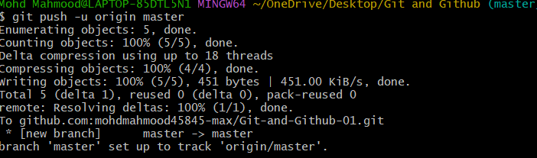
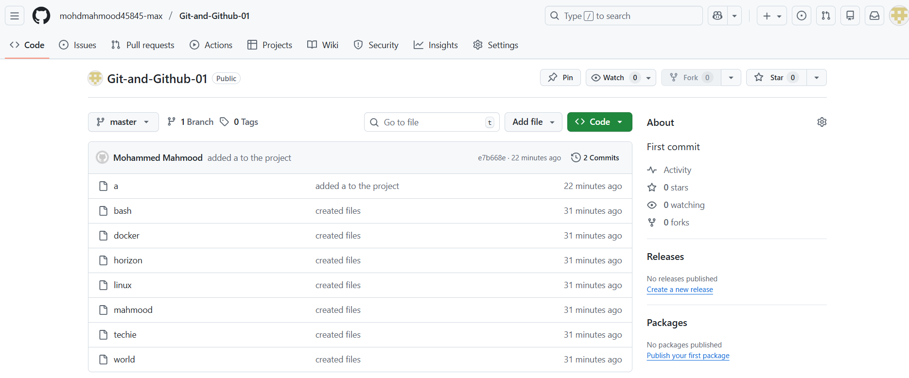
- Delete the file in both local machine and git hub
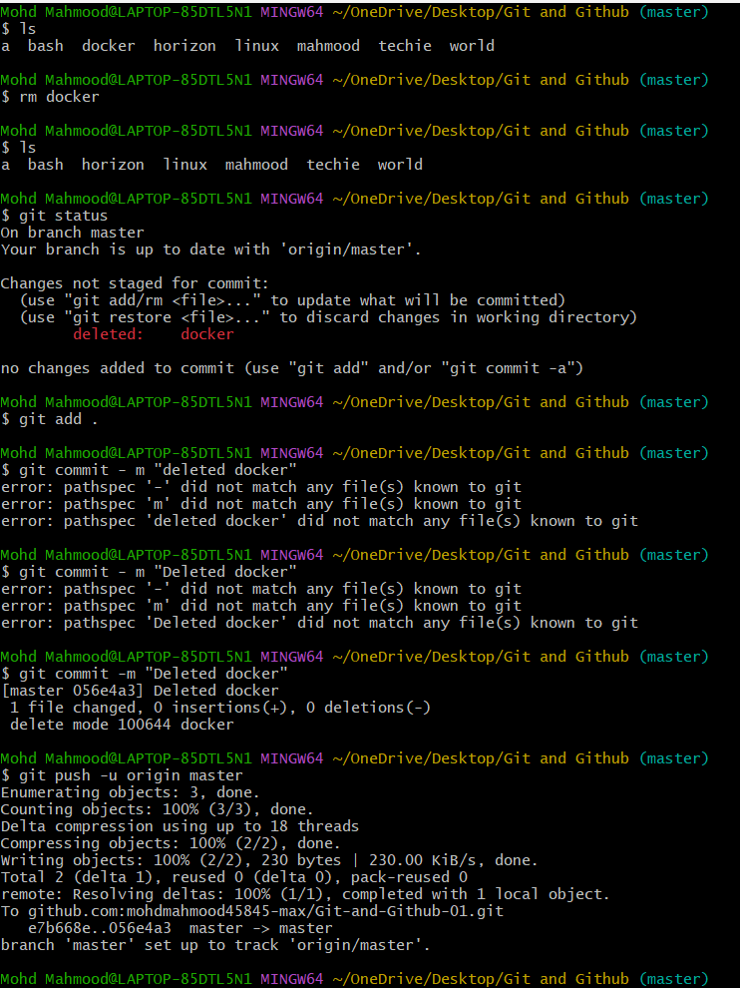
- To push file from github to local machine
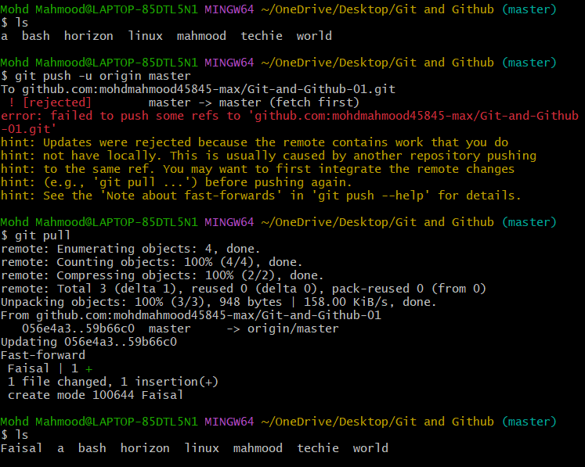
- Recover the deleted file
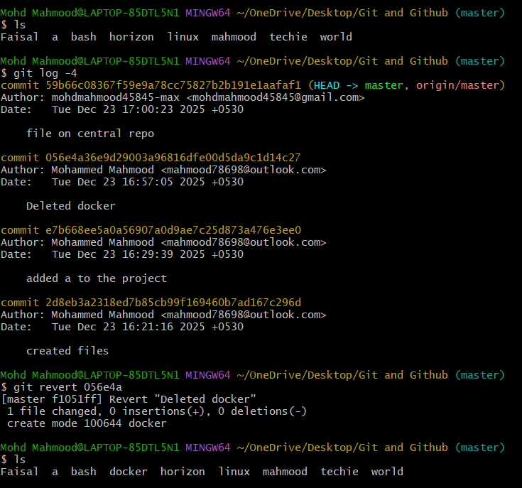
- Tracking and untracking
